|  |  |
| --- | --- |
| Immagine che contiene scuro, cielo notturno  Descrizione generata automaticamente  GHOST ‘N’ LOST  Game Development Group Project | Tommasina Redimson Arzillo Andrea Lozovanu Igor  Docenti  Babazadeh Masiar  Paoliello Marco |

Summary

Figure Summary 1

The idea of the game 2

Game Story 2

How does the game work 2

Connection to the theme of the Transmission 2

General structure of the game at code level 3

Interesting implementation detail 4

Screenshots of the game in action 4

Link 6

Repo Code 6

World Assert Download 6

# **Figure Summary**

Figure 1 - Code Diagram 3

Figure 2- Start Page 4

Figure 3 - Tutorial (pt.1) 4

Figure 4 - In Game, Ghost dimension (first person view) 5

Figure 5 - In Game, Human dimension (third person 2 view) 5

Figure 6 - In Game, Ghost dimension (third person 1 view) 5

Figure 7 - Game Win 6

Figure 8 - Game Over 6

# The idea of the game

3D game in which we impersonate a ghost, who travels through two dimensions in search of his material body.

# Game Story

You are a researcher who has been sent, with his team, to a small town that has been declared uninhabitable for reasons that have not been made public, one day you wake up but notice something strange.... you are a ghost...

From your studies you remember that a body begins its decomposition 48 hours after death, you know that this is the maximum time you have to try to return to your body, the problem is that you no longer remember the last hours before your death and therefore do not know where to find your body, here begins your adventure ...

# How does the game work

The ghost moves between two dimensions (planes), the material and the ghost world.

In the ghost world he can only see other ghosts, some enemies, and some friends. Those enemies will attack him, and he has to defeat them in order to build up a charge that he can use to survive in the material world in order to find his corpse. Weapons such as swords or chains etc. can be used to defeat enemy ghosts.

Friendly ones can give him bonuses.

In the material world, the accumulated charge will be discharged over time and while he wanders around looking for his body, he can scare the NPCs present to accumulate more charge. Similarly, if he moves in the material world during the day, he will be damaged by light and will have to hide from light rays to limit the damage. In addition, NPCs can use mirrors to see him and attack him.

The game ends with a loss if the body to be resurrected is not found within a time limit, otherwise the player wins.

# Connection to the theme of the Transmission

The link between this game and the theme of transmission is the ability of the ghost to pass from the dimension of ghosts to the earthly, human dimension. The aim of the game can also be linked to the theme of transmission, that is, to find one's own body and 're-transmit' the soul back to life.

# General structure of the game at code level

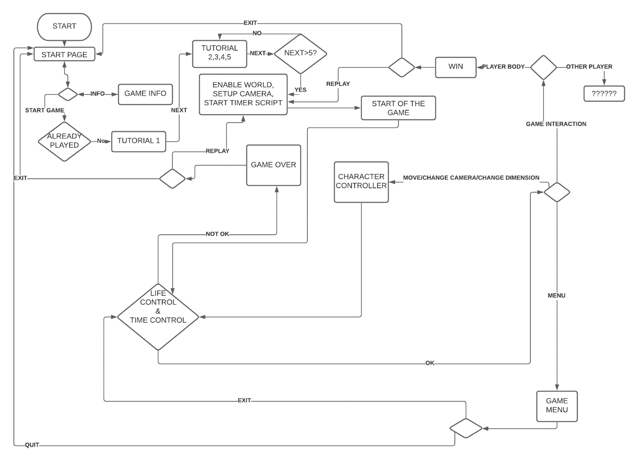

Figure 1 - Code Diagram

The code scripts that are used are:

* Start page
  + Managing the actions that can take place on the start page
  + Handles the start of the tutorial
* Tutorial Control
  + Handles the tutorial
  + Does the initial setup before starting the game
* TimerTime
  + Manages the timer
  + Notify the system if the time runs out
* Energy
  + Manages energy
  + Notify the system if energy runs out
* Pause Control
  + Manage when the game should be paused
* SettingsPopUp
  + Manage the in-game user menu
* Game Over
  + Manages the defeat
* Game Win
  + Manages the win
* GameOverWinMenu
  + Handles the win/loss menu
* CharController_Motor
  + For movement management
  + For managing camera changes
  + For managing the size change

# Interesting implementation detail

# Screenshots of the game in action

Figure 2- Start Page

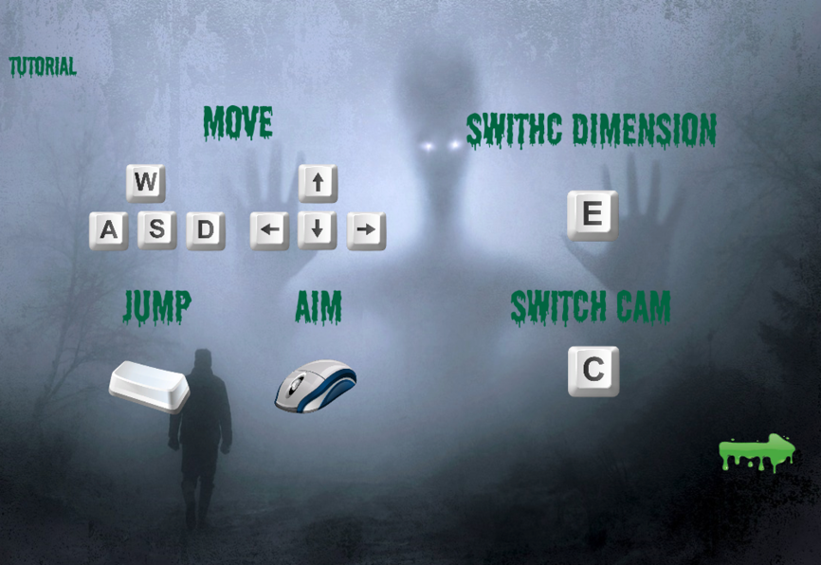

Figure 3 - Tutorial (pt.1)

Figure 4 - In Game, Ghost dimension (first person view)

Figure 5 - In Game, Human dimension (third person 2 view)

Figure 6 - In Game, Ghost dimension (third person 1 view)

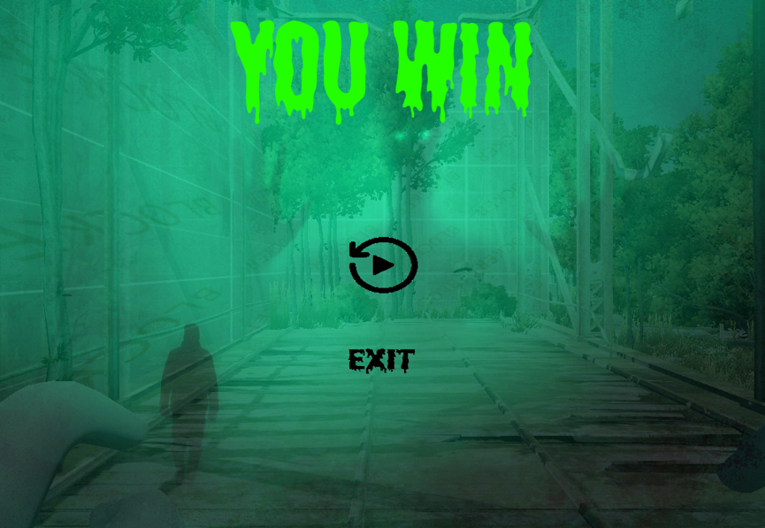

Figure 7 - Game Win

Figure 8 - Game Over

# Link

## Repo Code

* <https://github.com/andreaarzillo/game_dev>

## World Assert

* <https://assetstore.unity.com/packages/3d/environments/flooded-grounds-48529>